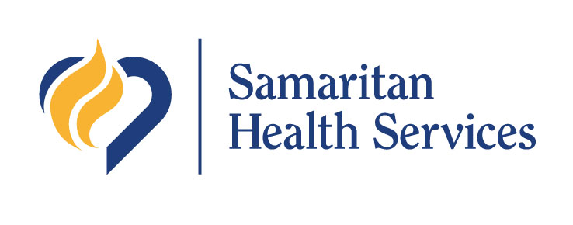3600 NW Samaritan Drive

Corvallis, OR 97330

www.samhealth.org

*Building Healthier Communities Together*

Samaritan Health Services

Hospital Social Accountability Grants

Proposal Template

Proposals due Nov. 7, 2025

Email proposal & budget to [communityhealth@samhealth.org](mailto:communityhealth@samhealth.org)

# Section 1: Face Page

|  |  |
| --- | --- |
| Organization Name |  |
| Project Title |  |
| Primary Contact Name & Title |  |
| Primary Contact Email Address |  |
| Primary Contact Phone Number |  |
| Mailing Address |  |
| Requested Grant Amount *(select one)* | $5,000  $10,000  $25,000  $50,000 |
| Project Service Area *(select one or more)* | Linn County  Lincoln County  Benton County |

# Section 2: Project Narrative (4-5 pages)

*Please respond to each of the following prompts:*

1. Describe the project and its goals, including consideration of key partnerships and conditions for success.
2. Explain how the project aligns with the [Regional Community Health Improvement Plan (CHIP)](https://www.lblpartnershipforhealth.org/).
3. Identify the target population (including geographic area served) and strategies for outreach and engagement.
4. Explain who will benefit from this project.

# Section 3: Workplan & Timeline (1-2 pages)

*Provide a detailed workplan including key activities, responsible parties, and timeline for implementation. Please ensure that project activities are clearly related to the project goals described in Section 2.*

# Section 4: Budget Narrative (1 page)

*Fill out the “2026 Social Accountability Budget Template” Excel file and include with your proposal submission. Use this space to explain how funds will be used. Please include a justification for each line item.*